Figure1. Topographic Map of the Eureka Site.

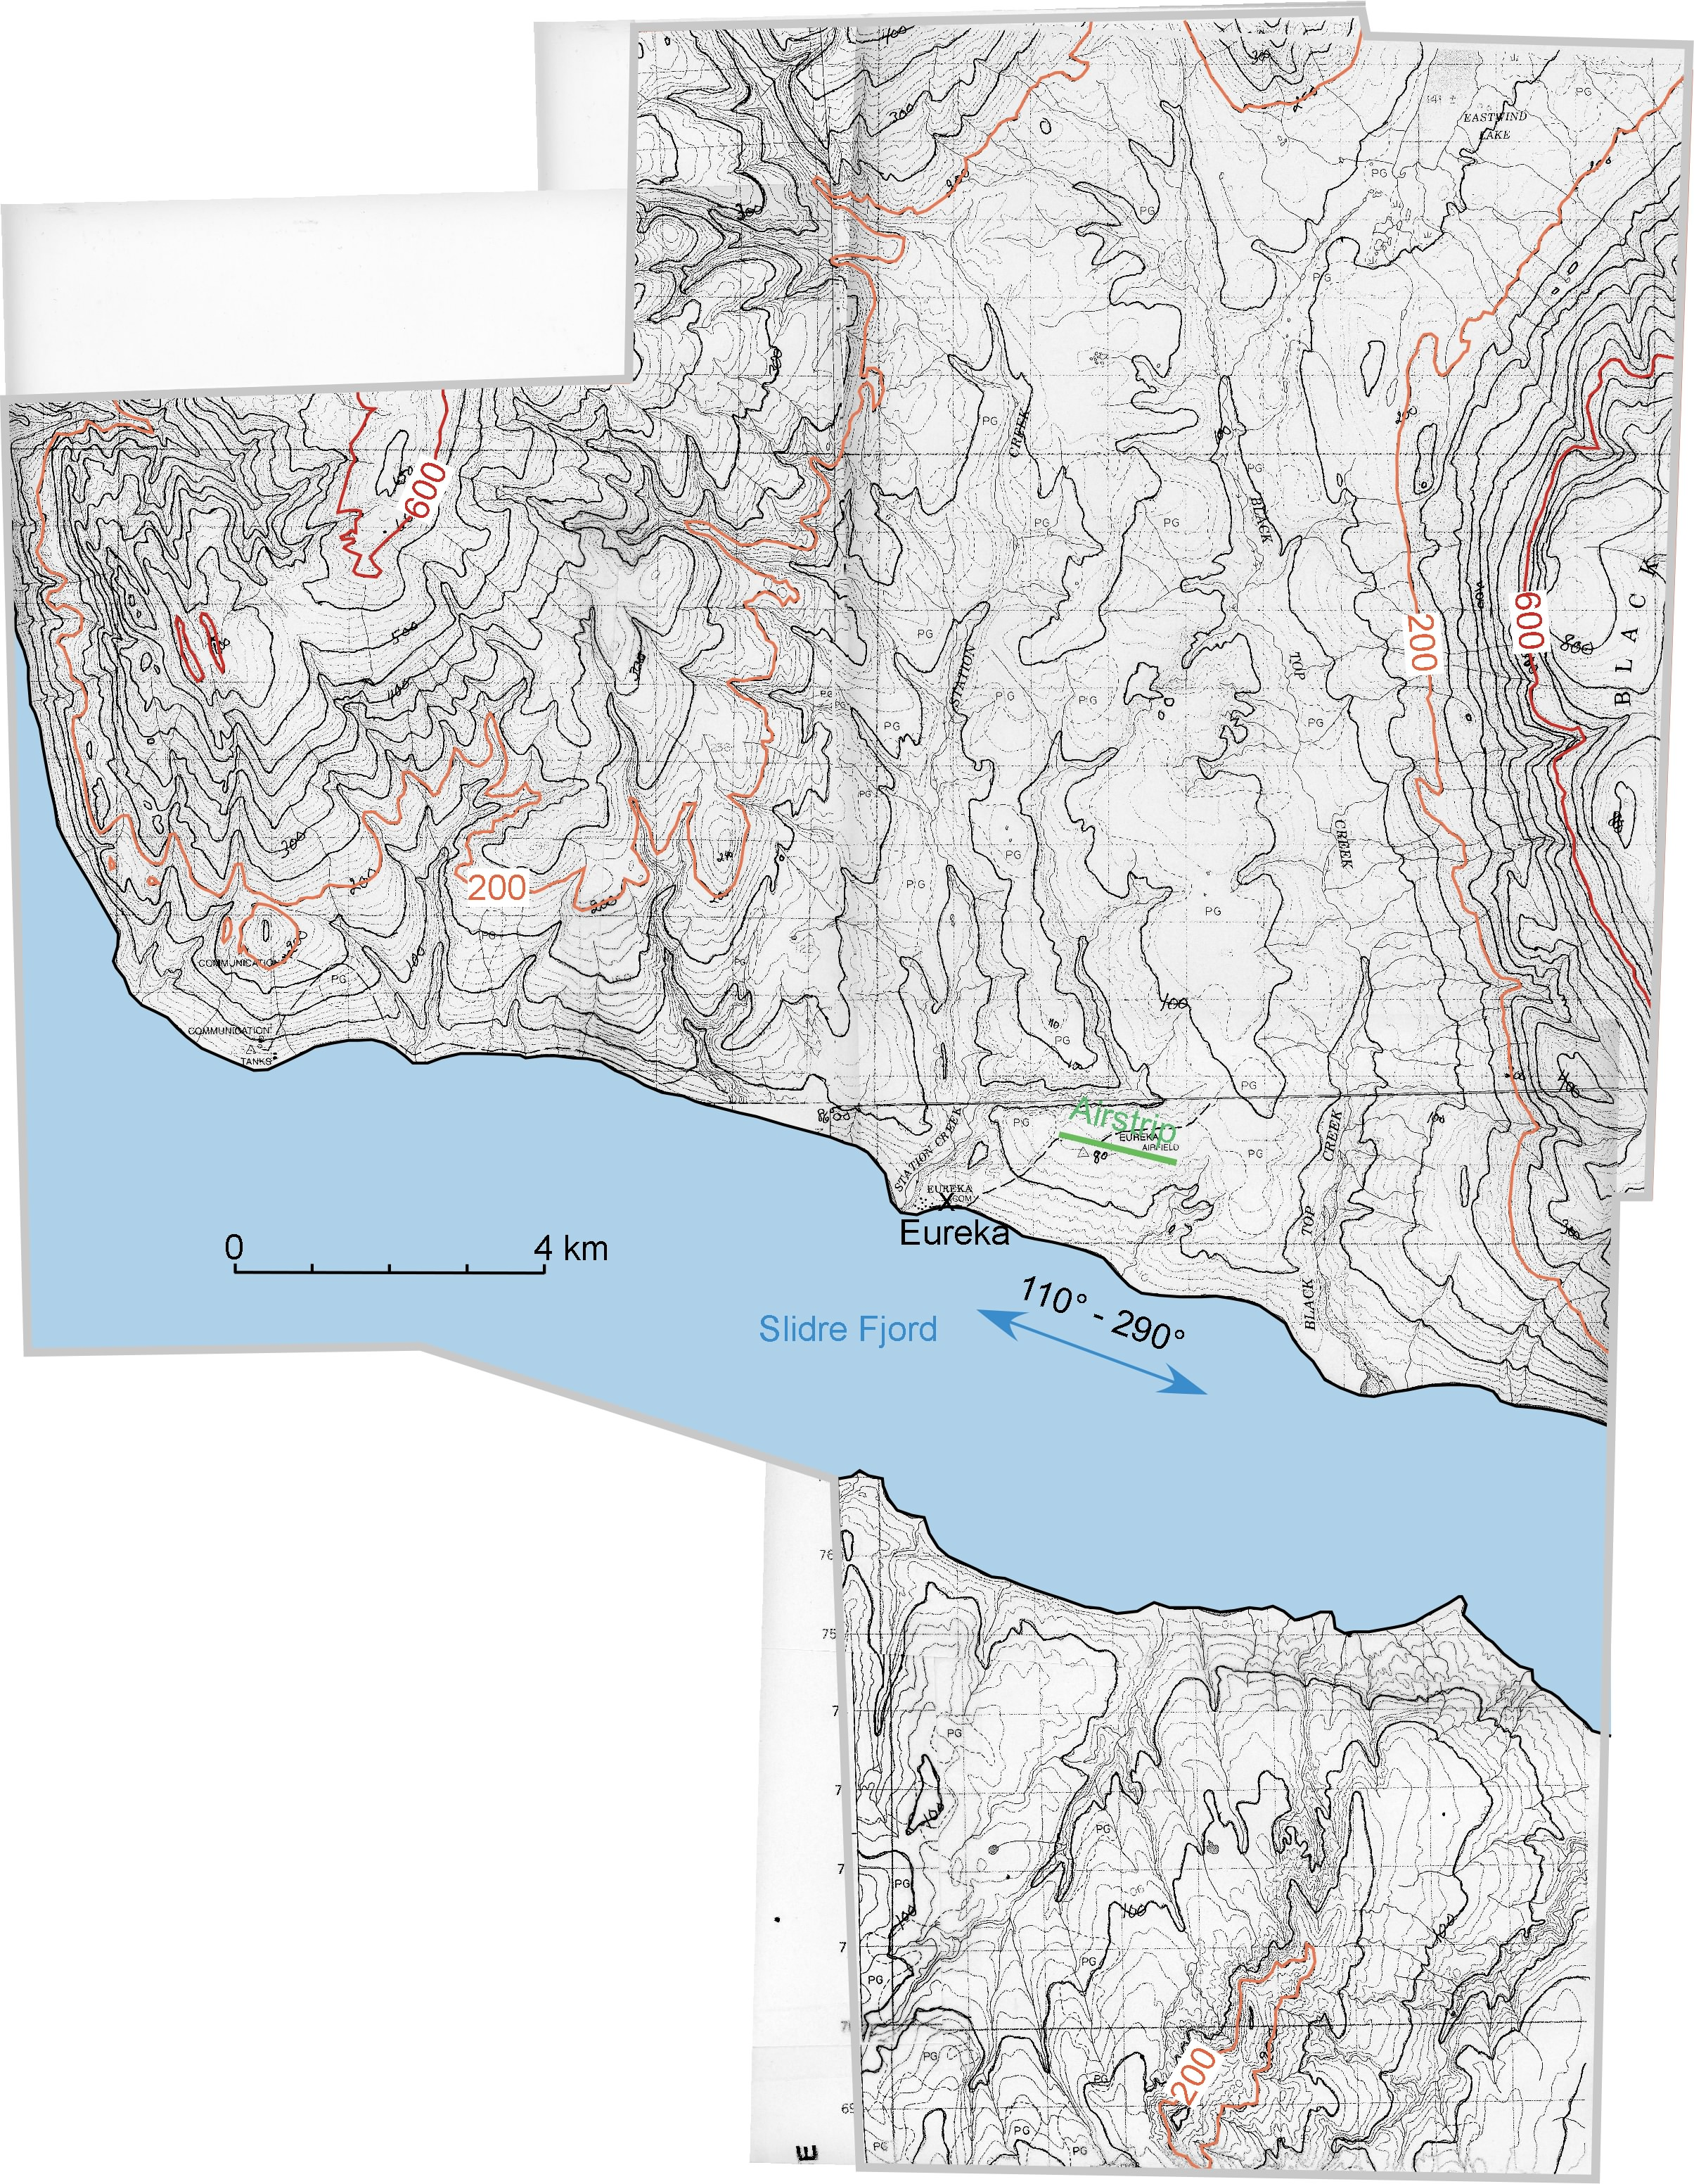

Figure2. Maps of the Proposed (a) and Preferred Eureka Sites (b) and Wind Rose Estimation at the Elevation of the Tower Site from Sounding Data.

a)

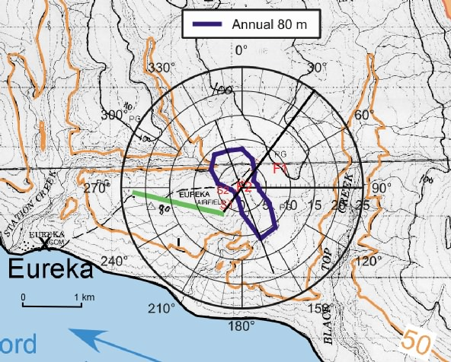

b)

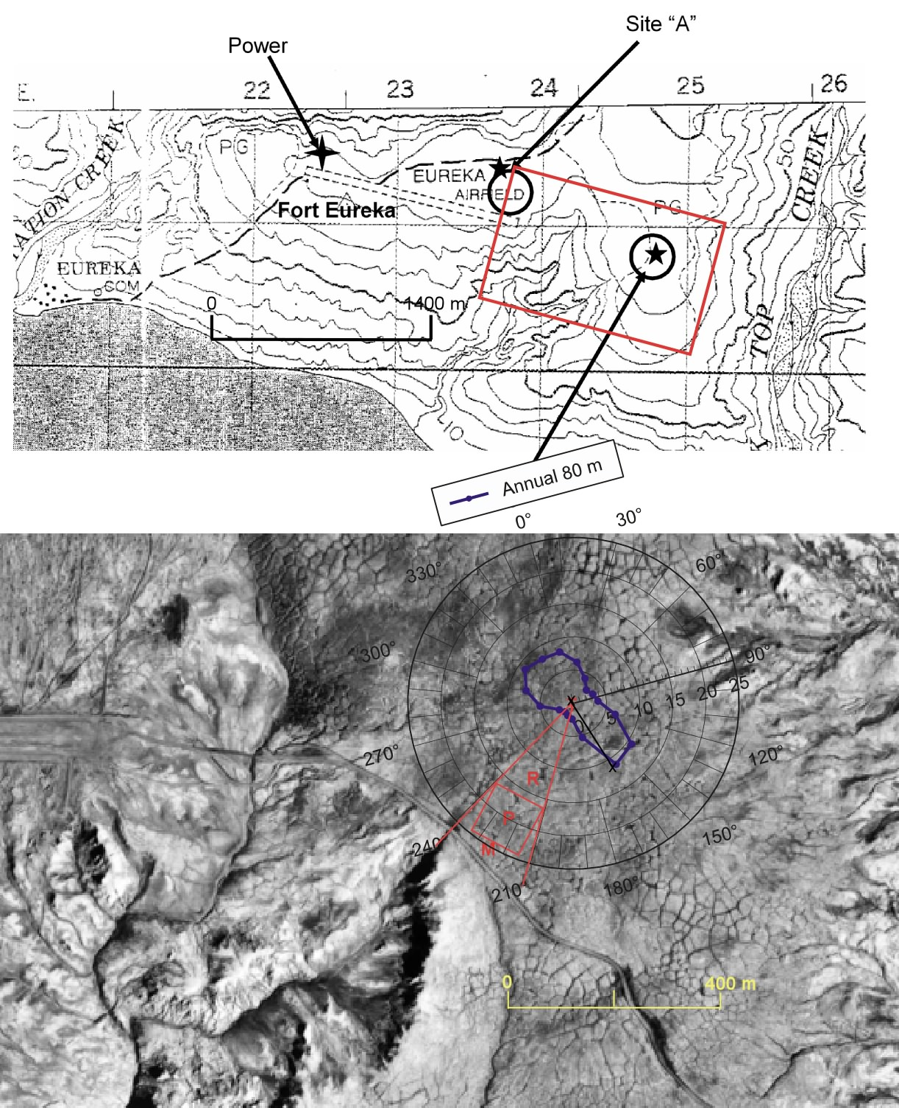

Figure 3. Looking Down on the Grass to the Left and Mud to the Right.

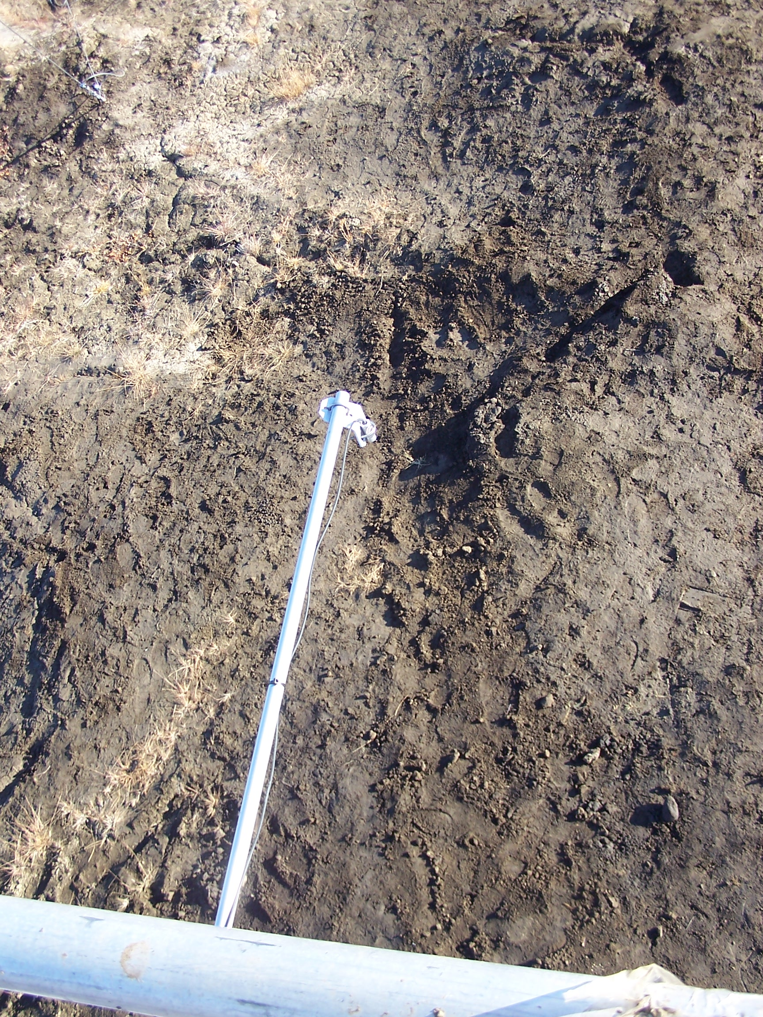

Figure 4. North West View of the Flux Tower.

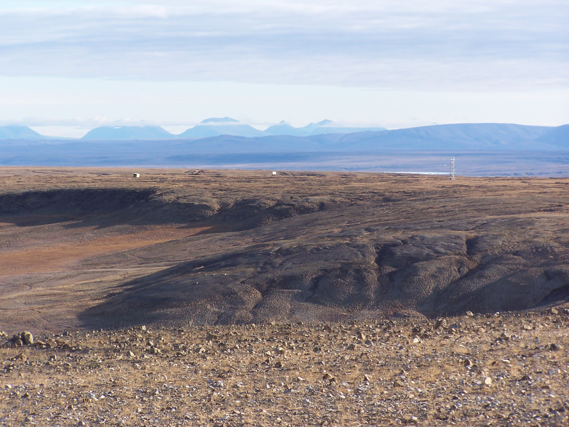

Figure 5. Panoramic View from the Flux Tower.

